M Ghulam Murtaza ***LAB # 2***

***2018-CS-131***

**ANSWER 1:**

***UML***

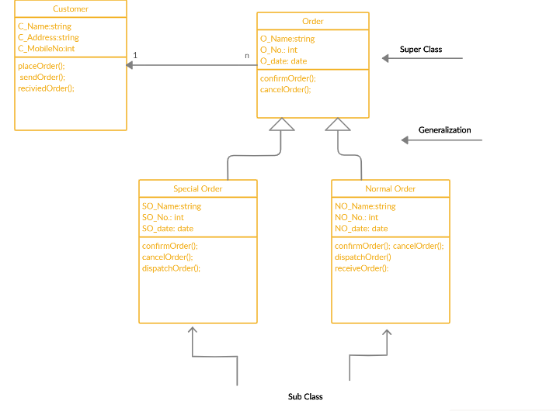

**ANSWER 2:**

***UML***

